Sprint Planning 1 – 22/10/19

Sprint goal: This week we hope to finish most of the planning aspects of our project and complete the integration of API’s with a song search algorithm implemented.

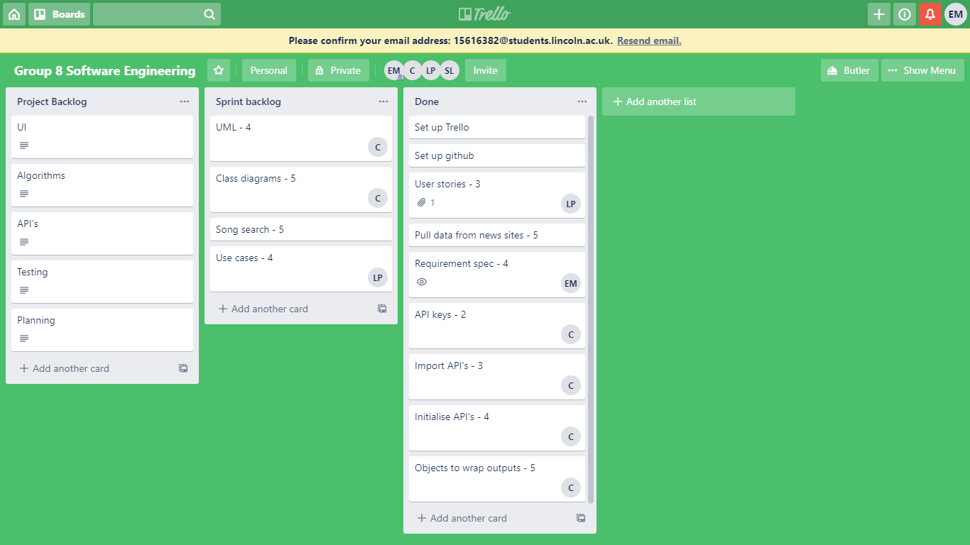

(Unfortunately this week we forgot to screenshot the sprint backlog, however it was everything in the done section plus the remnants of sprint backlog.)

Sprint Retro 1 – 29/10/19

Elliott – This week I have written the requirements for our project as a whole. This included user requirements and functional requirements.

Callum – This week I have completed all the importing and initialising of the API’s for our project. I have created a form that allows users to pull songs from Spotify based on a search term and pulls news headlines from multiple different sources.

Luke – This week I created user stories for the project to allow help with development of requirements.

Alex –

Shiyan –

Unfortunately we did not complete everything that we placed into the sprint backlog. This was our first sprint and we over estimated how much we would be able to complete within our short time constraints. We realised part way through the sprint we may not get the creation of a song list based on news completed so adapted to still produce a deliverable. Our deliverable for this sprint was the planning and the creation of a form that fetches songs based on user input and that would fetch news headlines. This shows the client that we are on the way to creating the product and shows the API’s that we are using.

Sprint planning 2 – 29/10/19

Sprint Goal: Develop a deliverable that will show the user the creation of a playlist based on the news with limited customisation options and limited UI.

This week we plan to complete all of the main algorithms to that will create the playlists for the users based on the news. We also hope to begin some of the UI aspects of the development.

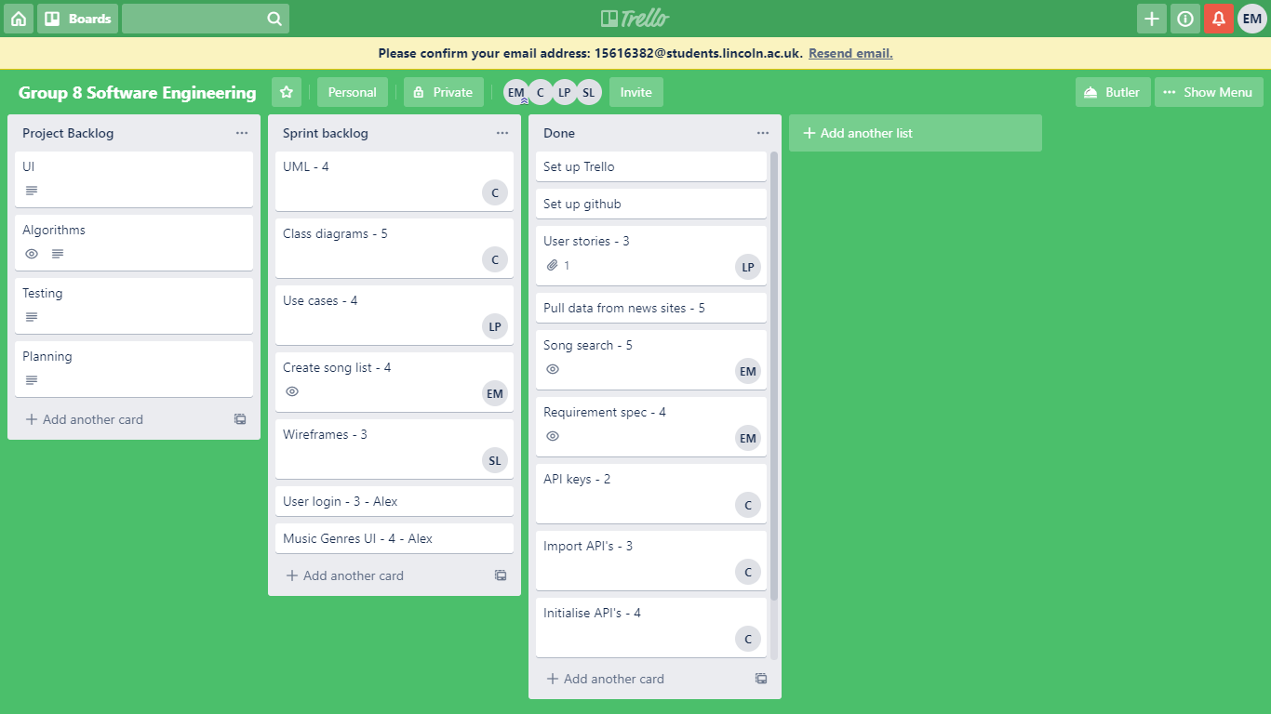

This will be the assigned sprint backlog for this week’s sprint.

Sprint Retro 2 – 5/11/19

Elliott – This week I have implemented the algorithm that will return a list of Spotify songs based on the news location and category. It returns this through the current form UI.

Callum – This week I have finalised the UML Class Diagram to be up to date with the current build. I have also gone through the project and fixed any bugs that have been found during testing, and I have committed a pull request. I have also worked on paired programming with Elliot.

Luke- This week I created use case diagrams. I derived use cases from the requirements, produced a traceability matrix, use case diagrams and use case schemas. I then began working on creating domain models by deriving them from the use case.

Alex – This week I created fork on the github repository and added a windows form application for the user interface based on the diagram designed already, I created a pull request which was accepted and thus the UI was added to the main project

Shiyan – This week I created wireframe of application interface and uploaded to github.

This week we have completed our sprint goal. We completed all but two of the assigned tasks which is a significant improvement upon week one. The two we didn’t complete were user login and music genres UI however Alex contributed to developing an overall design of the UI rather than music genres.

Sprint planning 3 – 5/11/19

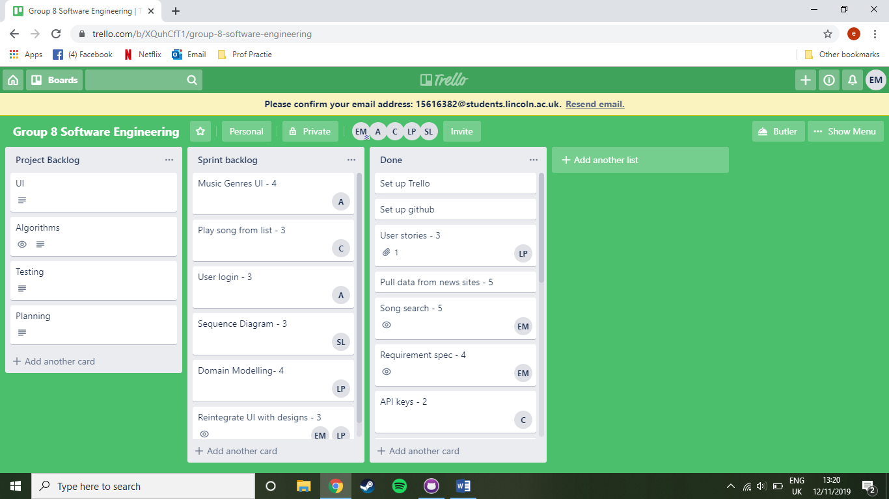

Sprint Goal: Complete our application to a publishable standard, including linking to Spotify songs on click and completing all design sections.

Sprint Retro 3 – 12/11/19

Elliott – This week I implemented the UI designs along with changing form functionality with Luke through paired programing.

Luke- This week I completed the domain modelling diagrams and the traceability matrix for the domain modelling. Furthermore, through pair programming with Elliott, I implemented the UI designs and ensured functionality. I then did further formatting to the UI.

Callum – This week I completed adding the functionality for double clicking songs in our song list to take you directly to the song within spotify.

Shiyan – This week I completed and updated sequence diagrams.

Sprint Planning 4 – 12/11/19

This week we plan to refine our code. We are going to refine our search terms to remove redundant words such as “The” or “And” to allow for more relevant songs in the playlist. As well as this we plan to refine our UI to a professional standard.

